Петар Антиќ III-1 MIG
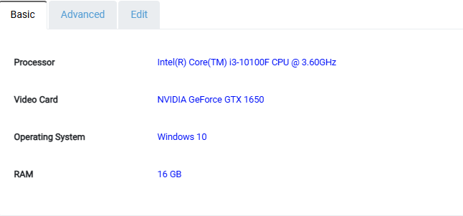
Avr. 19681908µs --Selection sort
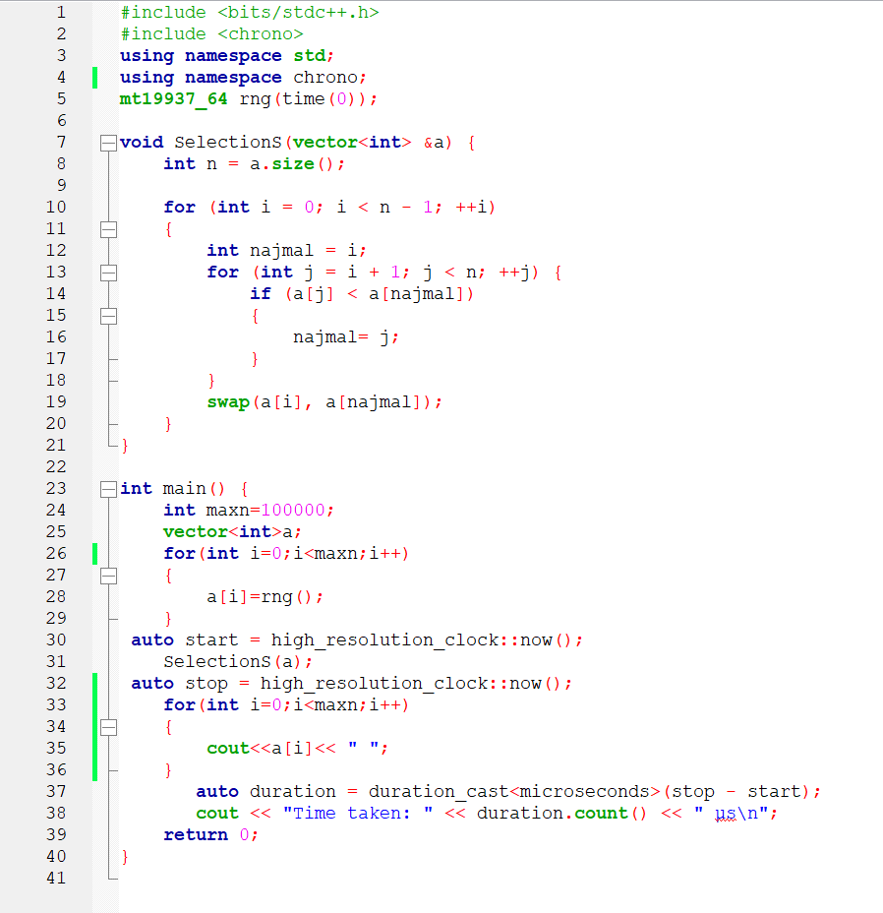
Avr. 61045µs—Merge sort
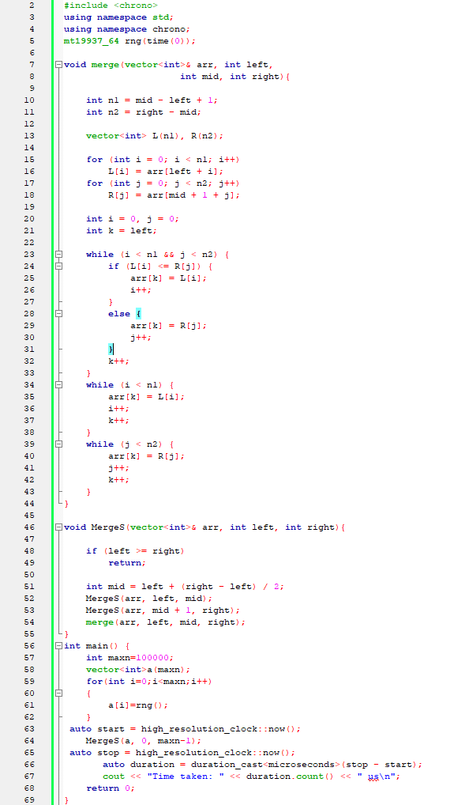
Avr. 357342µs—Insertion sort
